**How to Build a Sine Wave Generator with a 555 Timer Chip**

 

In this circuit, we will show how we can build a sine wave generator with a 555 timer chip.

A sine wave generator is a device which can generate sine waves.

Sine waves are waveforms which alternate in values during a cycle. It has a peak value, the highest amplitude it attains and a trough value, the lowest amplitude it obtains. The sine wave in between the peak and trough takes on an infinite number of values in between the peak and trough value.

Sine waves are actually very common. One of the most frequent places you will find them is in household electricity sockets. Out of household electricity sockets comes out AC sine voltage signals.

In the United States, the sine waves have a frequency of 60Hz, meaning there are 60 cycles in a second. In countries throughout the world, the frequency is either 50Hz or 60Hz. In the United States, the amplitude of AC voltage is 120V or 240V. Throughout the world it varies from as low as 110V to 240V.

You will also see sine waves in function generators. Function generators usually can output AC signals in sine wave, square wave, or triangle waveform.

Sine waves are also used a lot in acoustics.

In this circuit we will use a 555 timer to create a sine wave signal that can be used for a variety of purposes.

**Components**

* 555 Timer Chip
* 2 10KΩ resistors
* 100nF ceramic capacitor
* 10nF ceramic capacitor
* 10μF electrolytic capacitor

The 555 timer can be obtained very cheaply from pretty much any electronic retailer.

The 555 timer is an 8-pin chip.

If you want to know all the pinout of the 555 timer, what each pin is and what each pin does, see [555 Timer Pinout](http://www.learningaboutelectronics.com/Articles/555-timer-pinout.php).

In this circuit, we will connect the 555 timer to be in astable mode.

In this mode, the 555 timer will go from HIGH to LOW, HIGH to LOW, HIGH to LOW.

The connections are shown below.

**Sine Wave Generator Using a 555 Timer**

The sine wave generator circuit that we will build is shown below.   
  
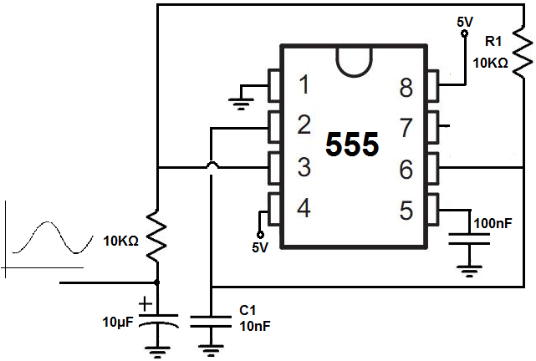

The breadboard schematic of the above circuit is shown below.   
  
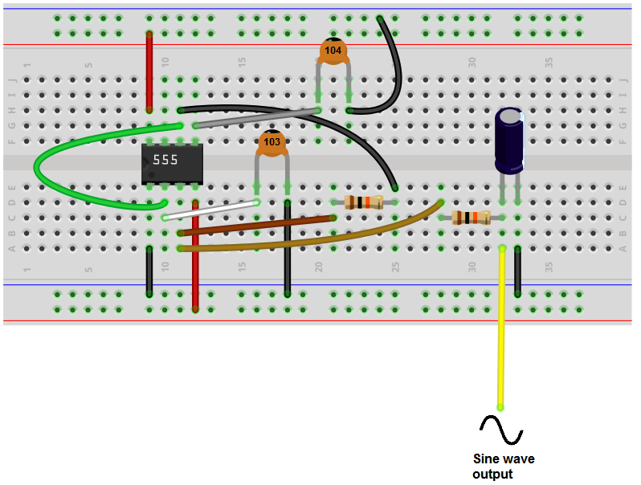

This 555 timer is in astable mode.

Astable mode can produce digital square waveforms that go back and forth between HIGH and LOW.

With a resistor and capacitor placed in series at the output, the digital square wave transforms into a sine wave. The capacitor has a smoothing effect so that unlike a digital signal which is either ON or OFF, the change isn't so abrupt with a capacitor at the output. Instead of going completely ON or OFF right away, which is what happens with a square wave signal, the signal changes slower and not abruptly, so it mimics a sine wave signal.

When the circuit is turned on, capacitor C1 is uncharged and the otuput pin 3 is HIGH. So the signal is in the HIGH state at this point.

Then capacitor C1 charges up via the R1 resistor and when Pin 6 detects 2/3rd of the voltage supply, then the output goes LOW.

Resistor R1 now discharges capacitor C1 and when pin 2 detects 1/3 of the supply voltage, the output goes HIGH, repeating the cycle.

The duty cycle of this signal is 50%. The duty cycle is the amount of time in a given cycle that the signal is HIGH. Being that this circuit has a duty cycle of 50%, the HIGH and LOW time of a signal is equal. The signal is ON and OFF for the same amount of time.

The frequency of this signal is about 27KHz.

Changing the value of the R1 resistor and the C1 capacitor changes the frequency of the signal.

To create a 3.7KHz signal, R1= 10KΩ and C= 100nF.

To create a 23KHz signal, R1= 1KΩ and C= 100nF.

To create a 112KHz signal, R1= 10KΩ and C= 1nF.

To create a 115KHz signal, R1= 1KΩ and C= 10nF.

To create a 505KHz signal, R1= 1KΩ and C= 1nF.